**HTML Forms <form>**

|  |  |
| --- | --- |
| **Forms, Graphics, and Interactive Elements** | **Abstract**  Forms and input elements enable data collection through various input types and attributes. |

* <form> is a HTML element to collect input data with containing interactive controls. It provides facilities to input text, number, values, email, password, and control fields such as checkboxes, radio buttons, submit buttons, etc
* Forms are generally used when you want to collect data from the user. For example, feedback form, login form, complaint form, inquiry form etc.

## **Form tags**

|  |  |  |
| --- | --- | --- |
| **Tag / Element** | **Description** | **Syntax / Example** |
| **<form>** | Container used to collect and submit user input to a server. | <form action="/submit" method="post">  ... form elements ... </form> |
| **<fieldset>** | Groups related form elements together inside a box. | <fieldset>  </fieldset> |
| **<legend>** | Caption/title for a <fieldset>. | <fieldset>  <legend>Login Details</legend> </fieldset> |
| **<input>** | General input field (text, password, number, etc.). | <input type="text" >  <input type="email" > |
| **<textarea>** | Multi-line text input field. | <textarea rows=”20” cols="30">Enter your message</textarea> |
| **<button>** | Clickable button (can be submit, reset). | <button type="submit">Submit</button> |
| **<label>** | Defines a label for form elements; improves accessibility. | <label for="uname">Username:</label> <input type="text"> |
| **<datalist>** | Provides a list of predefined suggestions for an <input>. | <input list="browsers" name="browser"> <datalist id="browsers">  <option value="Chrome">  <option value="Firefox"> </datalist> |
| **<select>** | Creates a drop-down list. | <select name="cars">  <option value="volvo">Volvo</option>  <option value="bmw">BMW</option> </select> |
| **<option>** | Defines an item inside a <select> or <datalist>. | <select>  <option value="html">HTML</option>  <option value="css" selected>CSS</option> </select> |
| **<optgroup>** | Groups related <option> elements inside a <select>. | <select>  <optgroup label="Frontend">  <option>HTML</option>  <option>CSS</option>  </optgroup>  <optgroup label="Backend">  <option>PHP</option>  <option>Python</option>  </optgroup> </select> |

## **Form Attributes**

| **Attribute** | **Description** | **Default Value** |
| --- | --- | --- |
| action | URL where form data will be sent after submission. | "" (empty) |
| enctype | The enctype attribute specifies how the form-data should be encoded when submitting it to the server.  **Note:** The enctype attribute can be used only if method="post". | application/x-www-form-urlencoded  Form data is encoded as key-value pairs, joined with & and spaces converted to +. |
| method | HTTP method (GET or POST) used when submitting. | GET |
| type | Defines the type of <input> (text, password, etc.). | text |
| name | Name of the field (used as key when submitting data). | "" (empty) |
| id | Unique identifier for an element | "" (empty) |
| value | Default value for an input. | "" (empty) |
| placeholder | Hint text shown inside an input before typing. | "" (empty) |
| required | Makes the field mandatory before form submission. | false |
| readonly | Field is visible but not editable; value is submitted. | false |
| disabled | Field is visible but inactive; value is NOT submitted. | false |
| checked | Pre-selects a checkbox or radio button. | false |
| maxlength | Maximum number of characters allowed. | Unlimited |
| minlength | Minimum number of characters required. | 0 |
| step | Defines intervals for numeric/date inputs (e.g., step='2'). | 1 (depends on input type) |
| min | Minimum allowed value for number/date inputs. | No restriction |
| max | Maximum allowed value for number/date inputs. | No restriction |
| multiple | Allows selecting multiple values (e.g., multiple files or emails). | false |
| accept | Specifies file types accepted in a file upload input. | All file types |
| autocomplete | Enables or disables autocomplete suggestions. | on |
| autofocus | Automatically focuses on an input field when the page loads. | false |
| rows | Defines visible rows in a <textarea>. | No fixed default (browser-dependent) |
| cols | Defines visible width (columns) in a <textarea>. | No fixed default (browser-dependent) |
| selected | Pre-selects an option in a <select> menu. | false |
| list | Connects an <input> with a <datalist> for suggestions. | None |

## **<input> Types**

|  |  |  |
| --- | --- | --- |
| **Input Type** | **Description** | **Syntax / Example** |
| **text** | Single-line text field. | <input type="text" name="username" id="uname" placeholder="Enter username" required maxlength="20"> |
| **password** | Hides typed characters (for passwords). | <input type="password" name="pwd" id="pwd" placeholder="Enter password" required minlength="6"> |
| **email** | Input for email addresses (validates format). | <input type="email" name="email" id="email" placeholder="name@example.com" required> |
| **number** | Numeric input with min/max/step controls. | <input type="number" name="age" id="age" min="1" max="100" step="1" value="18"> |
| **tel** | Telephone number input (may show number pad on mobile). | <input type="tel" name="phone" id="phone" placeholder="1234567890"> |
| **checkbox** | Allows selecting one or more options. | <input type="checkbox" name="hobby" value="music" checked> Music <input type="checkbox" name="hobby" value="sports"> Sports |
| **radio** | Allows selecting one option from a group. | <input type="radio" name="gender" value="male" checked> Male <input type="radio" name="gender" value="female"> Female |
| **submit** | Button to submit the form. | <input type="submit" value="Submit Form"> |
| **reset** | Button to reset all form fields. | <input type="reset" value="Reset Form"> |
| **button** | General button (custom actions via JavaScript). | <input type="button" value="Click Me"> |
| **file** | Allows file selection/upload. | <input type="file" name="resume" id="resume" accept=".pdf,.doc" multiple> |
| **hidden** | Hidden input (not shown to user, but submitted). | <input type="hidden" name="userid" value="12345"> |
| **date** | Date picker (calendar). | <input type="date" name="dob" id="dob" min="2000-01-01" max="2025-12-31" value="2020-05-15"> |
| **range** | Slider control for selecting a numeric value. | <input type="range" name="vol" id="vol" min="0" max="50" step="5" value="25"> |
| **color** | Color picker input. | <input type="color" name="favcolor" id="favcolor" value="#ff0000"> |

**GET Method:**

• Appends the form data to the URL, in name/value pairs

• NEVER use GET to send sensitive data! (the submitted form data is visible in the URL!)

• The length of a URL is limited (2048 characters)

• Useful for form submissions where a user wants to bookmark the result

• GET is good for non-secure data, like query strings in Google

**POST Method:**

• Appends the form data inside the body of the HTTP request (the submitted form data is not shown in the URL)

• POST has no size limitations, and can be used to send large amounts of data.

• Form submissions with POST cannot be bookmarked align: It aligns form in left or right or center.

* **HTML <select> tag**
* <select> tag is used to create a drop-down list with multiple options. The <option> element is nested within <select> tag for defining options in a list.
* The <select> element is used to create a drop-down list. The <select> element is most often used in a form, to collect user input.
* The <optgroup> tag is used to group related options in a <select> element (drop-down list). If you have a long list of options, groups of related options are easier to handle for a user.
* The <option> tag defines an option in a select list.

**Attributes**

* **disabled:** Specifies that an option should be disabled
* **selected:** Specifies that an option should be pre-selected when the page loads.
* **hidden:** The option with the hidden attribute is not visible in the dropdown list, but it remains in the HTML code, and its value can still be accessed programmatically (e.g., through JavaScript).
* **Value:** Specifies the value to be sent to a server

**Optgroup and selected,hidden,disabled example**

<select name="degree_branch">

    <option value="select" **selected disabled**> Select Branch</option>

    <optgroup label="Computer">

        <option value="cse"> CSE </option>

        <option value="cst"> CST </option>

        <option value="ce"> CE </option>

        <option value="it"> IT </option>

    </optgroup>

    <optgroup label="Other">

        <option value="ec"> EC </option>

        <option value="civil"> Civil </option>

        <option value="Mech"> Mechanical </option>

    </optgroup>

</select>

**Selected attribute keeps the option selected at first time we load the web page.**

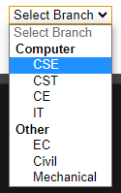

**Disabled attribute disables the option. We cannot select the disabled option.**

<select name="degree_branch">

    <option value="select" **selected hidden**> Select Branch</option>

    <optgroup label="Computer">

        <option value="cse"> CSE </option>

        <option value="cst"> CST </option>

        <option value="ce"> CE </option>

        <option value="it"> IT </option>

    </optgroup>

    <optgroup label="Other">

        <option value="ec"> EC </option>

        <option value="civil"> Civil </option>

        <option value="Mech"> Mechanical </option>

    </optgroup>

</select>

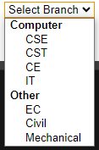

**Hidden attribute hides the option.**

### **readonly,disabled and hidden**

### **1. readonly**

* **Behavior:** The field is visible and its value can be **submitted** with the form, but the user **cannot edit** it.
* **Use case:** Showing a value that should not be changed but still sent to the server.

### **2. disabled**

* **Behavior:** The field is visible but **grayed out**, **cannot be edited**, and **is not submitted** with the form.
* **Use case:** Temporarily disabling a field based on a condition.

### **3. hidden**

* **Behavior:** The field is **not visible at all** on the page, but its value **is submitted** with the form.
* **Use case:** Passing extra data to the server without showing it to the user (like user ID).

**Example**

    <h2>Form Example: readonly, disabled, hidden</h2>

    <form action="/submit" method="POST">

        <!-- Readonly field -->

        <label>Username (readonly):</label>

        <input type="text" name="username" value="LJU" readonly>

        <br><br>

        <!-- Disabled field -->

        <label>Promo Code (disabled):</label>

        <input type="text" name="promo" value="SUMMER50" disabled>

        <br><br>

        <!-- Hidden field -->

        <input type="hidden" name="userId" value="12345">

        <!-- Editable field -->

        <label>Email:</label>

        <input type="email" name="email" placeholder="Enter your email" required>

        <br><br>

        <button type="submit">Submit</button>

    </form>

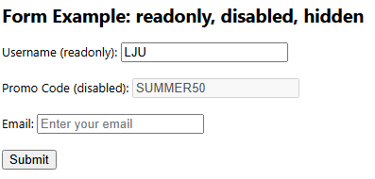

**Example**

<h2>Student Registration Form</h2>

<form **action="submit.html" method="get"**>

**<!-- Personal Information -->**

    <fieldset>

**<legend>Information</legend>**

        <label **for="uname"**>Username:</label>

**<input type="text" name="username" id="uname" autofocus autocomplete="on" placeholder="Enter username" required maxlength="20"><br><br>**

        <label **for="pwd"**>Password:</label>

**<input type="password" name="pwd" id="pwd" placeholder="Enter password" required minlength="6"><br><br>**

        <label **for="email"**>Email:</label>

**<input type="email" name="email" id="email" placeholder="name@example.com" required><br><br>**

        <label **for="phone"**>Phone:</label>

**<input type="tel" name="phone" id="phone" placeholder="1234567890"><br><br>**

        <p>Gender:</p>

        <input **type="radio"** **name="gender" value="male" checked**> Male

        <input **type="radio"** **name="gender" value="female"**> Female <br><br>

        <p>Hobbies:</p>

        <input **type="checkbox"** **name="hobby" value="music" checked**> Music

        <input **type="checkbox" name="hobby" value="sports"**> Sports <br><br>

    </fieldset>

**<!-- Preferences -->**

    <fieldset>

        <legend>Additional Information</legend>

        <label for="dob">Date of Birth:</label>

        <input **type="date"** name="dob" id="dob" **min="2025-09-07" max="2025-12-31"**><br><br>

        <label for="age">Age:</label>

        <input **type="number"** name="age" id="age" **min="1" max="100" step="1" value="18"**><br><br>

        <label for="favcolor">Favorite Color:</label>

        <input **type="color"** name="favcolor" id="favcolor" **value="#ff0000"**><br><br>

        <label for="browser">Preferred Browser:</label>

        <input **list**="**browsers**" name="browser" id="browser">

        <**datalist** **id**="**browsers**">

            <**option** **value="Chrome">**

            <**option** **value="Firefox"**>

            <**option** **value="Edge"**>

        </**datalist**><br><br>

        <label for="degree">Select Branch:</label>

        <**select** name="degree_branch" id="degree">

            <**option** value="select" **selected disabled**>Select Branch</option>

            <**optgroup** **label="Computer"**>

                <**option** **value="cse"**>CSE</option>

                <**option** **value="cst"**>CST</option>

                <**option** **value="ce"**>CE</option>

                <**option** **value="it"**>IT</option>

            </**optgroup**>

            <**optgroup** **label="Other**">

                <**option** **value="ec"**>EC</option>

                <**option** **value="civil"**>Civil</option>

                <**option** **value="mech"**>Mechanical</option>

            </**optgroup**>

        </**select**><br><br>

    </fieldset>

    <fieldset>

        <legend>Feedback</legend>

        <label for="msg">Your Message:</label><br>

        <**textarea** name="message" id="msg" **rows="5" cols="30"**>Enter your message</**textarea**><br><br>

        <label for="range">Satisfaction Level:</label>

        <input **type="range"** name="satisfaction" id="range" min="0" max="50" step="5" value="25"><br><br>

**<!-- Hidden value -->**

        <input **type="hidden"** name="userid" value="12345">

    </fieldset>

**<!-- Form Buttons -->**

    <fieldset>

        <legend>Submit Section</legend>

        <input **type="submit"** value="Submit Form">

        <input **type="reset"** value="Reset Form">

        <input **type="button**" value="Click Me">

        <**button** **type="submit"**>Submit (Button Tag)</**button**>

    </fieldset>

</form>

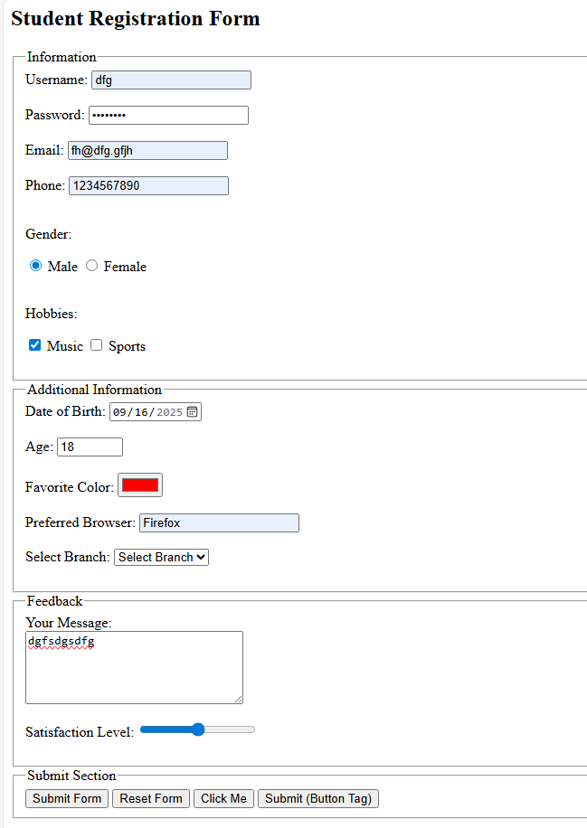

**autofocus and autocomplete=’on’ added as attributes**

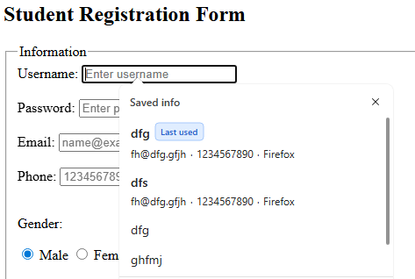

**Example**

Design an HTML form that allows users to **upload one or more files** to a server. The form should:

1. Include a file input field where the user can browse and select files.
2. Restrict the file types to only **PDF** (.pdf) and **Word Document** (.doc) formats.
3. Allow users to select **multiple files at once**.
4. Group the file input inside a **fieldset** for better structure.
5. Provide two buttons:
   * **Submit** → to send the selected file(s) to the server.
   * **Reset** → to clear the form and allow new input.
6. Use the **POST** method with enctype="multipart/form-data" so the files are correctly transferred in the request body.

<h1>File Upload</h1>

    <form action="submit.html" method="post" enctype="multipart/form-data">

    <!—Upload File -->

    <fieldset>

        <label for="resume">Upload Resume:</label>

        <input type="file" name="resume" id="resume" accept=".pdf,.doc" multiple><br><br>

    </fieldset>

    <br>

    <input type="submit"/>

    <input type="reset"/>

</form>

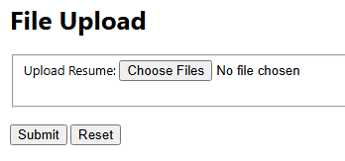

* The **accept attribute** is a **hint to the browser** about what file types should be selectable.
* <input type="file" accept=".pdf,.doc"> This tells the browser’s file picker: only show PDF and Word files as selectable.
* The file dialog (file chooser window) will **filter** and only show .pdf and .doc files by default.
* But in many browsers, the user can still change the filter (e.g., “All Files .”) and pick any file type (like .png, .exe).
* So accept is **not strict validation**. It’s a UI convenience.